**BSc (Hons) in Information Technology**

**Software Engineering – Year 3 Semester 2, 2022**

**SE3050 – User Experience engineering**

**Milestone 03**

**Team BIKO - SER_027**

IT20070458 O.K Wijewardena

Table of Content

Identification of the fail points …………………………………………………………………………………………………………………………03

* Fail point -01 ……………………………………………………………………………………………………………………………………….05
* Fail point -02 ……………………………………………………………………………………………………………………………………….06
* Fail point -03 ……………………………………………………………………………………………………………………………………….06
* Fail point -04 ……………………………………………………………………………………………………………………………………….07

User Key flows …………………………………………………………………………………………………………………………………………………08

* Diagram 01 …………………………………………………………………………………………………………………………………………08
* Diagram 02 …………………………………………………………………………………………………………………………………………09
* Diagram 03 …………………………………………………………………………………………………………………………………………10

Identification of the fail points

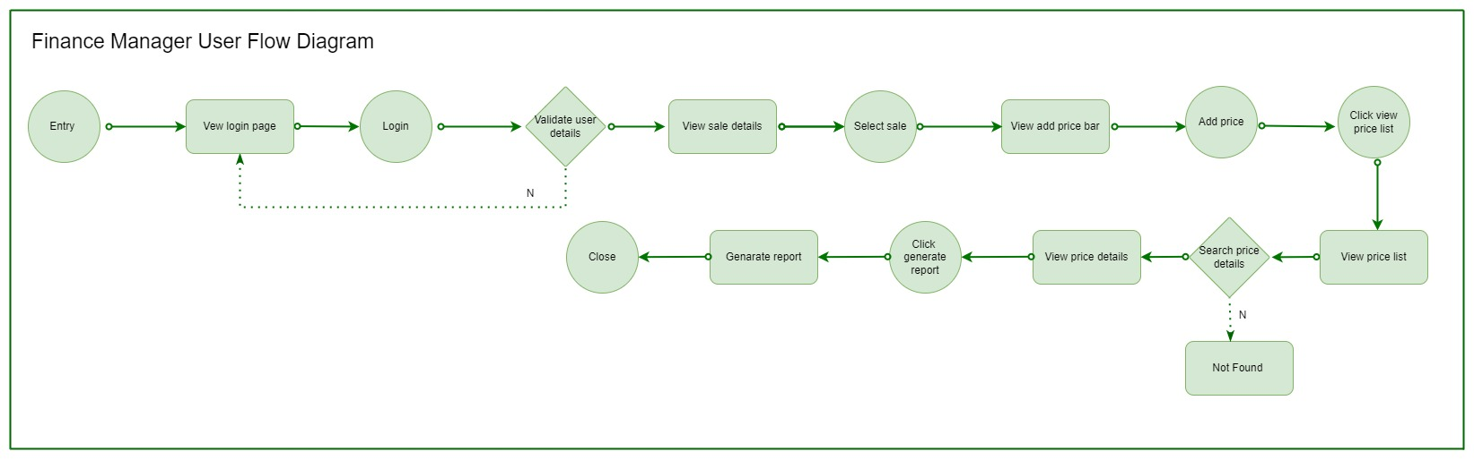

03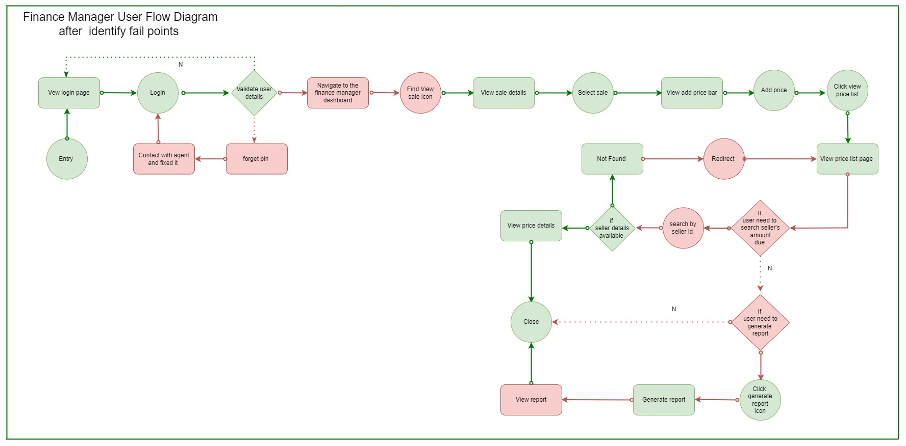

04

02

01







041

031

021

011

After completing the milestone 2, I can identify some fail points and blockings that we have done in milestone 1 user flow diagram.

In the user research, I identified 04 blockings with referring to the activities we have already done.

**Fail point – 01**

In above diagram one I can highlight the Fail point and diagram two represent the way that I overcome this fail point





-🡪

I assume with related to the use research and flow of the system, that is financial manger works to the factory and system admin is the person who create user profiles by after taking details. So, in the Mangers user flow I have not mention the registration part when correcting the user flow.

In here identified fail point is, if user forgot the user credentials, how user continue flow to complete the scenario.

By considering the user research and according to the user requirement I introduce the got pin option to contact the agent and fixed the issue.

**Fail Point -02**



🡪

In here identified fail point is, after successfully completing the onboarding process user need to navigate to the finance manager dashboard where the all the Icons and options available.

By considering the user research and according to the user requirement I introduce the finance manager dashboard which including icons.

**Fail point – 03**





🡪

In here identified fail point is, after search the seller details if the seller details not found user is block in that point so that I change the user for to redirect to the view price list page in order to the action perform by the user .

**Fail point – 04**





🡪

In here identified fail point is, after user visit the price list page if user need to search the price list of the customer by id scenario is not mentioned in the milestone 01 user flow. Therefore, as a change I introduce,

At first if user need to search a seller price list by id then if the details related to the user id available in the system, system view the price list to the user after that with user need to generate the report user can generate the report according the preference.

**Important: In My user journey I consider seller as Lorry drivers not tea sellers**

All above mentioned fail points are identified with reference to the user research

Video link: https://drive.google.com/drive/u/0/folders/1IsT5lM-f4yqEdf6N29uuMOGUJKazK66_

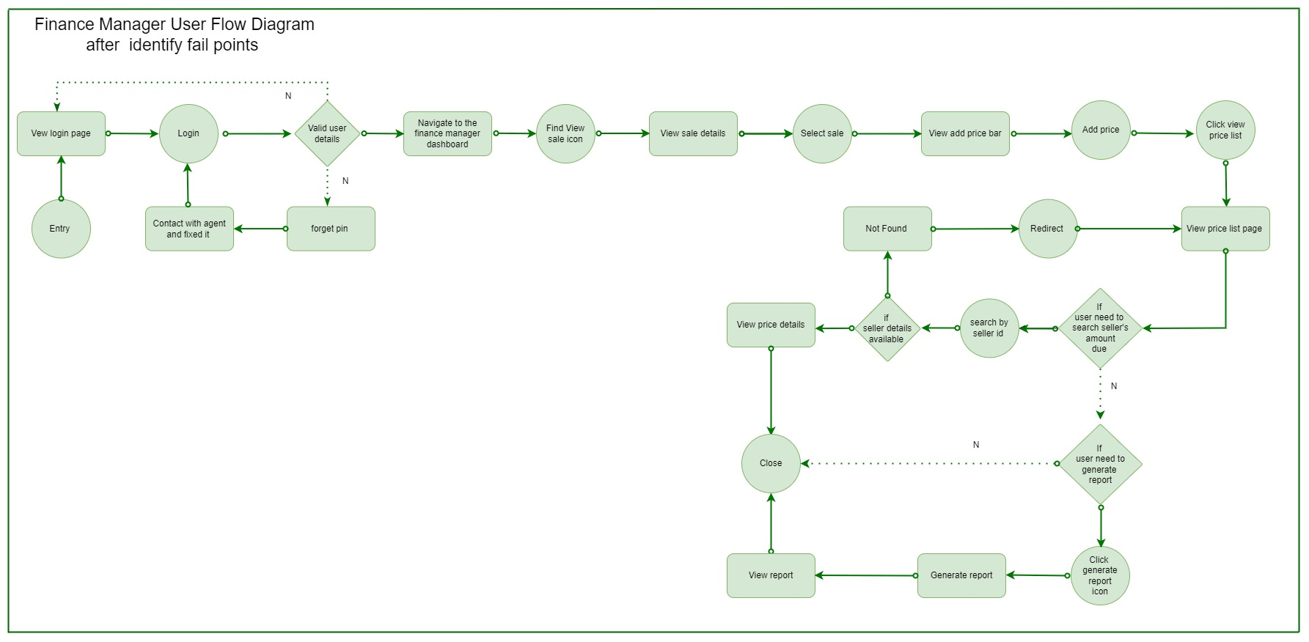User Key flows

Diagram 01

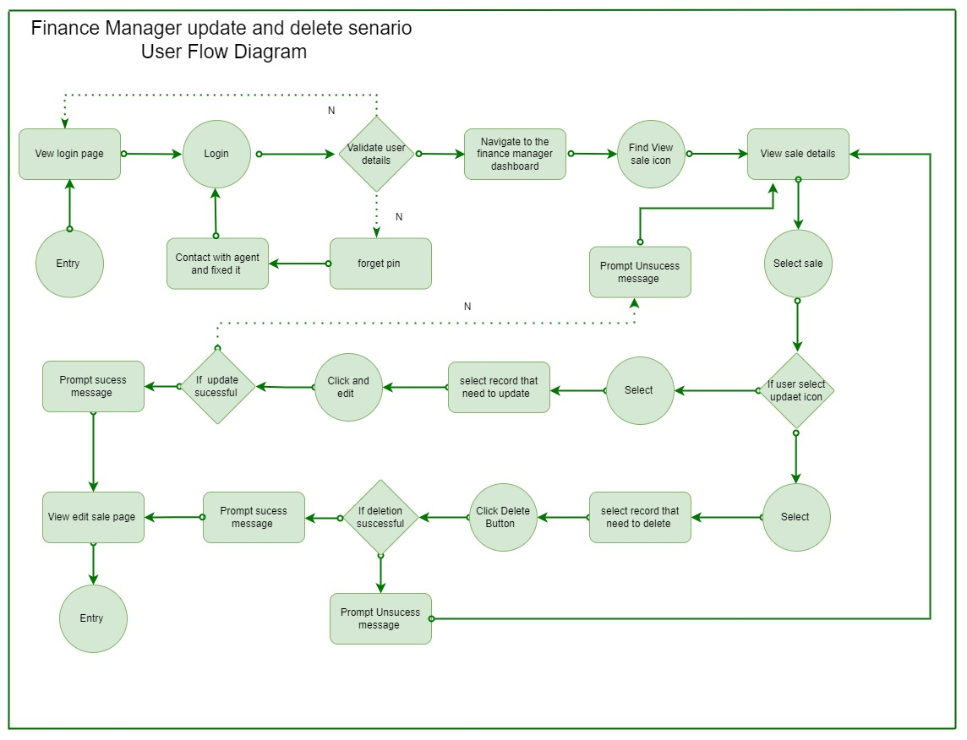 Diagram 02

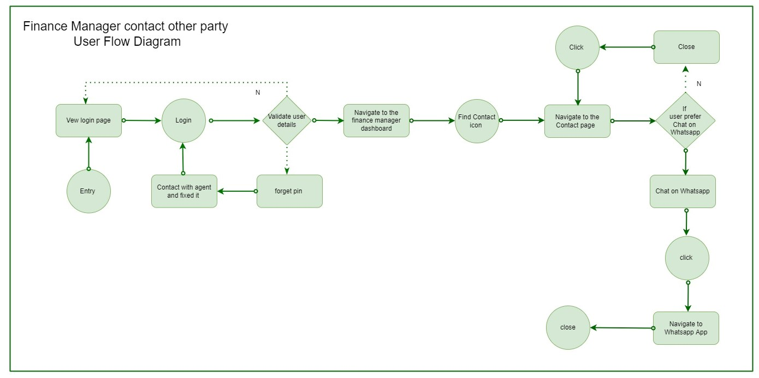

Diagram 03